75
Ability, motivation and opportunity  (AMO) | 08

CHAPTER OBJECTIVES

As an approach to managing, developing and motivating people, AMO is a
leading feature of strategic human resource management. It is set out in this
chapter under the following headings:

1 AMO defined

2 AMO and SHRM

3 The antecedents and development of AMO

4 Application of AMO

5 Practical implications
AMO defined
The AMO formula states that performance is a function of employee ability, motivation and opportunity. This can be expressed in the formula P = f (A.M.O). In other words, as Boxall and Purcell (2003: 20) put it, people per-form effectively when:
●they are able to do their job well because they have the necessary abilities in the form of knowledge and skills; as suggested by Dreyer and Docherty (2001) – cited by Boxall and Purcell (2003: 137) – this consists of ‘declarative knowledge’ (what we know about things) and ‘procedural knowledge’ (how we actually do things);
●they are motivated to do the work and to do it well;
●they have the opportunity to use their knowledge and skills in their job.
本书版权归Kogan Page所有

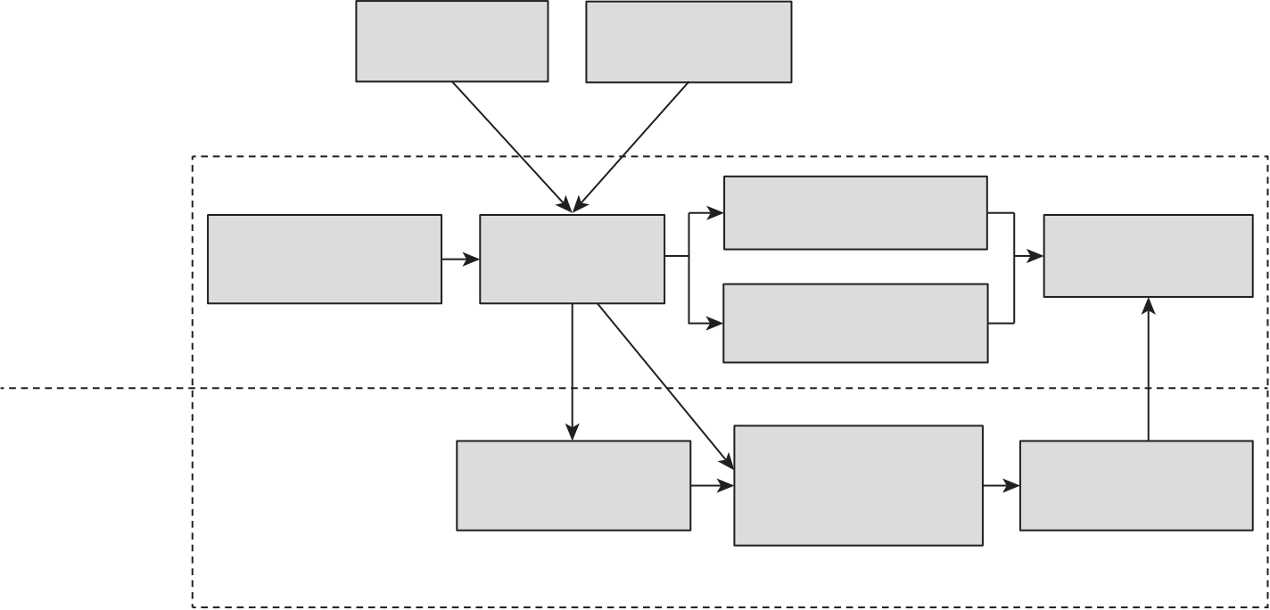
76 | Strategic Human Resource Management (SHRM)
Bos-Nehles et al (2023: 727) expanded this as follows:
Ability can be understood as physiological and cognitive capabilities that enable
an individual to perform a task effectively or, more generally, as employees’
knowledge, skills, competencies and proficiencies Motivation can be considered
as a force that directs, energizes, and sustains behaviour or the willingness
and desire of employees to perform a task. Finally, Opportunity covers the
contextual or environmental factors that are beyond the direct control of an
individual.
But as Bos-Nehles et al (2023) had previously commented, the nature of AMO interactions and their relationship with individual and organizational performance are topics of ongoing debate. They noted (p 863) that Boxall and Purcell (2003) had described performance as an ‘additive function’ using the formula P = ƒ(A+M+O) meaning that each element will affect perfor-mance. Bos-Nehles and her colleagues argued that: ‘Motivation and oppor-tunity by themselves cannot directly influence HRM performance without the necessary skills and knowledge to implement the HRM practices on the work floor. Ability is therefore a prerequisite for performance to occur.’
AMO and SHRM
SHRM is concerned with enhancing individual and organizational perfor-mance and how the AMO concept helps to do this is illustrated in Figure 8.1.
Figure 8.1 A model of strategic human resource management incorporating AMO
Organizational | Internal | External |  | Organizational
 | context | context
 | Organizational
 | Business/ | HRM system | capabilities
 | corporate strategy |  |  | performance
level
 | Collective employee
 | outcomes
Individual | Employee  experience |  | AMOs  Ability, motivation, opportunity | Individual
 |  |  |  | performance
level
SOURCE Adapted from Wilkinson et al (2013)
本书版权归Kogan Page所有

Ability, motivation and opportunity (AMO) | 77
The antecedents and development of AMO
The significance of the impact of motivation and ability on performance was identified by Vroom (1964). He devised the formula P = f (AM) where P is performance, A ability and M motivation. Note that the relationship be-tween ability and motivation is multiplicative, which means that perfor-mance is only possible when both ability and motivation exist. The absence of one or the other results in nil performance. But Campbell and Pritchard (1976: 91) observed that, although the formula Performance = (ability × mo-tivation) had been widely adopted, ‘its capability to account for additional variance in performance has been singularly unsuccessful’.
An important contribution to the development of AMO theory was made by Blumburg and Pringle (1982). Their theme was essentially that ability and motivation as incorporated in the Vroom performance formula were not enough. They asserted (p 562) that:
The serious shortcomings of the [Vroom] formulation become obvious when an
attempt is made to use it to organize what is known about work performance.
If the formulation is correct and complete, then each of the many variables that
affect work performance should be capable of being subsumed under either
the dimension of ability or that of motivation. In fact, however, a number of
relevant variables fall under neither of these categories.
Opportunity was also important. They defined opportunity (p 565) as:
the particular configuration of the field of forces surrounding a person and his
or her task that enables or constrains that person's task performance and that
are beyond the person's direct control. Opportunity interacts with capacity
and willingness to make performance more probable but, like willingness and
capacity, opportunity alone cannot ensure performance… all three elements –
opportunity, capacity, and willingness – must be present in some degree for
performance to occur.
The first time the AMO formula was mentioned in its present form was by Bailey (1993), who proposed that for the greater motivation of work-ers to translate into improved performance for the organization, they must have the skills required and participative organizational structures to apply their creativity, imagination and intimate knowledge of the work process effectively.
本书版权归Kogan Page所有

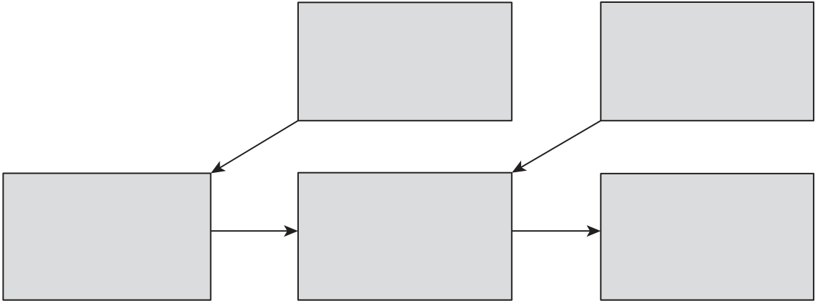
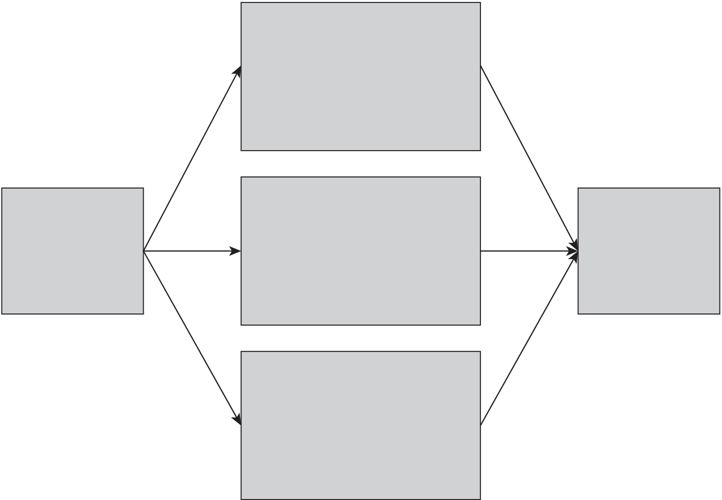
78 | Strategic Human Resource Management (SHRM)
The notion of AMO was taken up by Appelbaum and Batt (1994), who used the flow chart illustrated in Figure 8.2 to show how AMO worked and adopted it as a formula to analyse the impact of high-performance work systems in US industry.
In the UK, the first reference to AMO theory was made by Boxall and Purcell (2003). They noted that someone’s ability, motivation and opportu-nity to perform would depend on two groups of factors: 1) the individual’s experience, intelligence, health personality, etc; and 2) the situational factors
Figure 8.2 AMO and firm performance
• Opportunity | AMO | Behaviour
 |  | (effort)
 | Effective | Firm
to participate
 | discretionary
• Skills |  | performance
 | performance
• Incentives
SOURCE Adapted from Appelbaum and Batt (1994)
Figure 8.3 The AMO model as a framework for performance-enhancing HRM practices
Ability
• Sophisticated recruitment
and selection procedures
• Extensive learning and
development processes
• Talent management
programmes
Motivation
HRM initiatives | • Performance management | Individual and
 | • Performance pay | organizational
 | • Leadership development | performance
Opportunity
• Job design
• Work design
• Career management
programmes
本书版权归Kogan Page所有

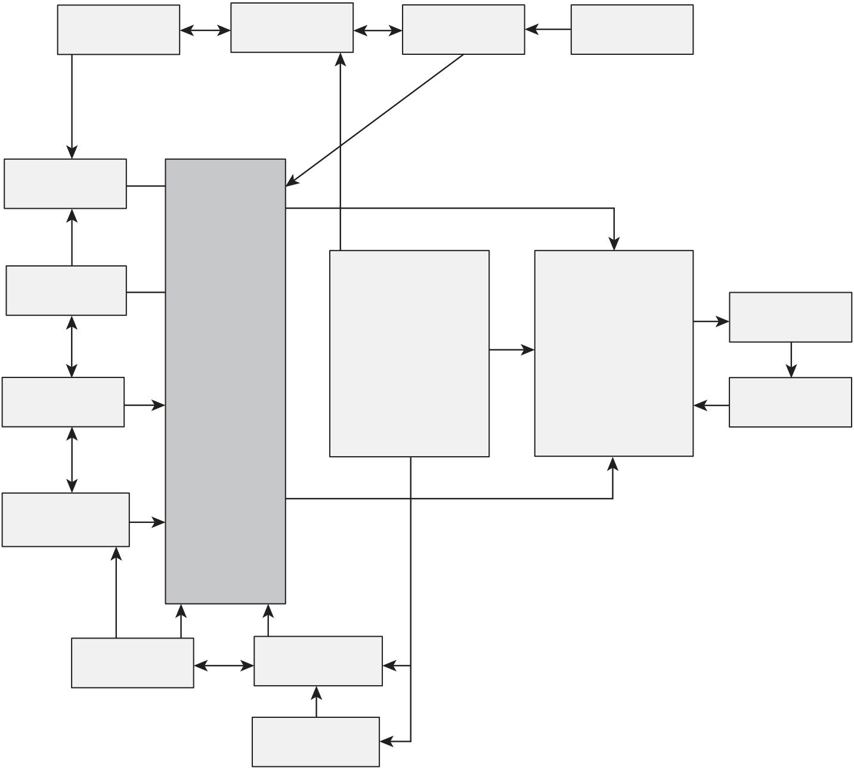
Ability, motivation and opportunity (AMO) | 79
Figure 8.4 The Bath people and performance model
Training and | Performance | Career | Job security
development | appraisal | opportunity
Recruitment/
selection | Ability and | Front-line | – Organization | Discretionary
Pay
 | skill
 |  | management
satisfaction |  |  | commitment
 |  | –implementing
 |  |  |  | behaviour
Work–life | Motivation | –enacting | – Motivation | Performance
 | and incentive | –leading
 |  |  | – Job satisfaction
balance |  | –controlling |  | outcomes
Opportunity
to participate
Job challenge/
autonomy
Teamworking Involvement
Communication
SOURCE Adapted from Purcell et al (2003)
of HR policies and practices oriented to creating ‘AMO’ and related varia-bles in the production system and the organizational context.
Kaufman (2015) argued that in order to achieve better performance, per-ceived as individual productivity, creativity and discretionary effort, compa-nies should focus on boosting the ability and motivation of employees while creating opportunities by giving them the necessary autonomy, tools and power to make decisions.
Application of AMO
The AMO formula can be used as a framework for developing performance-enhancing HRM strategies as shown in Figure 8.3.
本书版权归Kogan Page所有

80 | Strategic Human Resource Management (SHRM)
It can also be used as a basis for analysing the factors that affect organiza-tional performance. This is what Professor John Purcell and his colleagues from Bath University did in their investigation into the link between people and performance (Purcell et al, 2003). In that longitudinal research it was established that: ‘One of the prime functions of AMO policies is… the way they help develop attitudes or feelings of satisfaction, commitment and mo-tivation in most employees since these translate into discretionary behaviour if the job allows for it’ (p 7). Their illustration of the link between people policy and performance is set out in Figure 8.4.
PRACTICAL IMPLICATIONS
●Adopt a systems approach when using the model: ability is important but the other two factors – motivation and opportunity – have to be brought into play at the same time and the model dealt with as a whole.
●Avoid simplistic solutions to motivating people such as performance pay.
●Remember that the most important motivators are line managers and give special consideration to their development.
●Don’t underestimate the significance of the ‘opportunity’ factor. For example, job design is important.
References
Appelbaum, E and Batt, R (1994) The New American Workplace: Transforming work systems in the United States, Cornell University Press, Ithaca, NY Bailey, T (1993) Organizational innovation in the apparel industry, Industrial Relations: AJournal of Economy and Society, 32 (1), 30–48
Blumberg, M and Pringle, C D (1982) The missing opportunity in organizational research: Some implications for a theory of work performance, Academy of Management Review, 7 (4), 560–69
Bos-Nehles, A, Townsend, K, Cafferkey, K and Trullen, J (2023) Examining the ability, motivation and opportunity (AMO) framework in HRM research: Conceptualization, measurement and interactions, International Journal of Management Review, 25 (4), 725–39
本书版权归Kogan Page所有

Ability, motivation and opportunity (AMO) | 81
Bos-Nehles, A, Van Riemsdijk, M J and Looise, J K (2013) Employee perceptions of line management performance: Applying the AMO theory to explain the effectiveness of line managers’ HRM implementation, Human Resource
Management, 52 (6), 861–77
Boxall, P and Purcell, J (2003) Strategy and Human Resource Management, Palgrave Macmillan, Basingstoke
Campbell, J P and Pritchard, R D (1976) Motivation theory in industrial and organizational psychology, in Handbook of Industrial and Organizational Psychology, ed. M D Dunnette, Rand McNally, Chicago
Dreyer, G and Dougherty, T (2001) Human Resource Strategy: A Behavioural Perspective for the General Manager, Boston, MA, McGraw Hill Irwin
Kaufman, B E (2015) Theorising determinants of employee voice: An integrative model across disciplines and levels of analysis, Human Resource Management Journal, 25 (1), 19–40
Purcell, J, Kinnie, N, Hutchinson, S, Rayton, B and Swart, J (2003) Understanding the People and Performance Link: Unlocking the black box, CIPD, London Vroom, V (1964) Work and Motivation, Wiley, New York
Wilkinson, A, Bacon, N, Snell, S and Lepak, D (eds) (2013) The SAGEHandbook of Strategic Human Resource Management, 2nd edn, Sage, New York
本书版权归Kogan Page所有

